Statistical Performance Indicators
  - Somalia, Fed. Rep. Country Report

Introduction
Somalia, Fed. Rep. received a score of 51.7 out of 100 for 2024 on the World Bank’s Statistical Performance Indicator (SPI) overall score, which measures a country’s statistical performance around 5 pillars. These 5 pillars are described below. More information on the scoring for specific indicators can be found in the Annex table. Information on how the SPI data are put together can found in a journal article published in the journal Nature: Scientific Data.

Pillar 1: Data use
The data use (outcome) pillar is segmented by five types of users: (i) the legislature, (ii) the executive branch, (iii) civil society (including sub-national actors), (iv) academia and (v) international bodies. Each dimension would have associated indicators to measure performance. A mature system would score well across all dimensions whereas a less mature one would have weaker scores along certain dimensions. The gaps would give insights into prioritization among user groups and help answer questions as to why the existing services are not resulting in higher use of national statistics in a particular segment. Somalia, Fed. Rep. received a score of 60 out of 100 for 2024 on the World Bank’s SPI Pillar 1 score.

Pillar 2: Data services
The data services (output) pillar is segmented by four service types: (i) the quality of data releases, (ii) the richness and openness of online access, (iii) the effectiveness of advisory and analytical services related to statistics, and (iv) the availability and use of data access services such as secure microdata access. Advisory and analytical services might incorporate elements related to data stewardship services including input to national data strategies, advice on data ethics and calling out misuse of data in accordance with the Fundamental Principles of Official Statistics. Somalia, Fed. Rep. received a score of 48.7 out of 100 for 2024 on the World Bank’s SPI Pillar 2 score.

Pillar 3: Data products
The data products (internal process) pillar is segmented by four topics and organized into (i) social, (ii) economic, (iii) environmental, and (iv) institutional dimensions using the typology of the Sustainable Development Goals (SDGs). This approach anchors the national statistical system’s performance around the essential data required to support the achievement of the 2030 global goals, and enables comparisons across countries so that a global view can be generated while enabling country specific emphasis to reflect the user needs of that country. Somalia, Fed. Rep. received a score of 63.1 out of 100 for 2024 on the World Bank’s SPI Pillar 3 score.

Pillar 4: Data sources
The data sources (input) pillar is segmented by four types of sources generated by (i) the statistical office (censuses and surveys), and sources accessed from elsewhere such as (ii) administrative data, (iii) geospatial data, and (iv) private sector data and citizen generated data. The appropriate balance between these source types will vary depending on a country’s institutional setting and the maturity of its statistical system. High scores should reflect the extent to which the sources being utilized enable the necessary statistical indicators to be generated. For example, a low score on environment statistics (in the data production pillar) may reflect a lack of use of (and low score for) geospatial data (in the data sources pillar). This type of linkage is inherent in the data cycle approach and can help highlight areas for investment required if country needs are to be met. Somalia, Fed. Rep. received a score of 16.7 out of 100 for 2024 on the World Bank’s SPI Pillar 4 score.

Pillar 5: Data infrastructure
The data infrastructure (capability) pillar includes hard and soft infrastructure segments, itemizing essential cross cutting requirements for an effective statistical system. The segments are: (i) legislation and governance covering the existence of laws and a functioning institutional framework for the statistical system; (ii) standards and methods addressing compliance with recognized frameworks and concepts; (iii) skills including level of skills within the statistical system and among users (statistical literacy); (iv) partnerships reflecting the need for the statistical system to be inclusive and coherent; and (v) finance mobilized both domestically and from donors. Somalia, Fed. Rep. received a score of 70 out of 100 for 2024 on the World Bank’s SPI Pillar 5 score.

SPI Dimensions and Indicators
Each dimension of the five pillars incorporates several indicators. These Statistical Performance Indicators embody the granular measures of performance. They can be aggregated to levels of dimensions and pillars, and finally to an overall performance score to get a higher level or a more general perspective of a country’s performance.
The indicators are designed to act as proxy measures of performance for each dimension. While not comprehensive, they should add value in assessing country performance along that dimension. The intention is for the pillars and dimensions to be the focus rather than the specific indicators. The indicators for the SPI are selected following these principles: (i) use of publicly accessible data; (ii) transparent methodology; (iii) easy replicability; (iv) a time series to track performance; (v) clear portrayal of outcomes and their supporting elements; (vi) being reflective of the SDGs; (vii) enable at-a-glance comparisons on a global scale.
Benefitting from large scale data collection efforts by organizations such as the World Bank, IMF, Open Data Watch, PARIS21, the ILO, WHO, UNESCO, IHSN, and the UN, among others, 51 indicators covering 14 out of the 22 dimensions for the dashboard have been compiled. These 51 indicators provide data for each of the five pillars on data use, data services, data products, data sources, and data infrastructure. Yet, there remain major gaps in several pillars because indicators to assess performance still need to be developed, and in some cases, indicators have limited data coverage. This data availability challenge impedes efforts to measure the performance of statistical systems in certain areas and going forward countries and their international partners must work together to fill these gaps.
Below is a brief description of the indicators (or lack thereof) we have available for the 22 dimensions in the SPI framework. A detailed description of the indicators is also available in the annex. For as many as eight dimensions there was no indicator with a developed methodology, or the data collection for that measure was incomplete.
- Dimension 1.1: Data use by national legislature: Not included because of lack of established methodology. In principle it may be possible to utilize websites of national legislatures but this will require further work and assessment.
- Dimension 1.2: Data use by national executive branch: Not included because of lack of established methodology. There are some usable data sources (as used by PARIS21) but gaps in data across countries have prevented full adoption.
- Dimension 1.3: Data use by civil society: Not included because of lack of established methodology. There are some usable data sources with good coverage, for example from social media but more data is required to help assess and allow for likely biases between and within countries.
- Dimension 1.4: Data use by academia: Not included because of lack of established methodology. We have not been able to find usable data sources with global coverage on which a new methodology could be developed.
- Dimension 1.5: Data use by international organizations: Five measures of usefulness or reliability of country produced measures for international organizations have been included. First, on comparability of poverty estimates for the World Bank reporting on international poverty using PIP. Second on usable surveys for statistics on child mortality for the UN Inter-agency Group for Child Mortality Estimation. Third on accuracy of debt reporting as classified by the World Bank (Source: World Bank WDI metadata). Fourth, on availability of safely managed drinking water data for use by WHO/UNICEF Joint Monitoring Programme. Fifth, on labor force participation data for use by ILO. While these data sources provide only a partial coverag of data used by international organizations, they do provide an indication of the performance of the national statistical system. Somalia, Fed. Rep. received a score of 0.6 out of 1 for 2024 on this dimension.
- Dimension 2.1: Data Releases: SDDS/e-GDDS subscription. This indicator is based on whether the country subscribes to IMF SDDS+, SDDS, or e-GDDS standards. The source is the IMF Dissemination Standards Bulletin Board. This is a reliable data source but we recognize that it is a proxy for the concept we are seeking to capture rather than a direct measurement. Somalia, Fed. Rep. received a score of 0 out of 1 for 2024 on this dimension.
- Dimension 2.2: Online access: ODIN Open Data Openness score (Crowell et al). This is a well-established data source with good country coverage, which scores countries based on whether indicators are available online in a format that is machine readable, in a non-proprietary format, downloadable, with metadata available and terms of use. Scores range from 0-1. For more details, consult the ODIN technical documentation. Somalia, Fed. Rep. received a score of 0.5 out of 1 for 2024 on this dimension.
- Dimension 2.3: Advisory/ Analytical Services: Not included because of lack of established methodology. This could be a new indicator of the number of non-recurring products on NSO website (ad hoc/experimental rather than regular releases). The indicator is the number of products found. No established source exists for this indicator.
- Dimension 2.4: Data access services: NADA metadata. This indicator checks whether NADA microdata cataloging is available for surveys produced by NSO. NADA is an open source microdata cataloging system, compliant with the Data Documentation Initiative (DDI) and Dublin Cores RDF metadata standards. Source: NSO websites. Somalia, Fed. Rep. received a score of 1 out of 1 for 2024 on this dimension.
- Dimension 3.1: Social Statistics: Availability of indicators for the Sustainable Development Goals 1-6, measured by an average score. The primary data source is the UN SDG database. While this is a database with comprehensive coverage that all countries have signed up to, many countries are not yet submitting all their available national data. For this reason, scores for some countries thus may not fully capture their performance in calculating the indicators. For OECD countries, we supplement the UN SDG database with comparable data submitted to the OECD following the methodology in Measuring Distance to the SDG Targets 2019: An Assessment of Where OECD Countries Stand. Somalia, Fed. Rep. received a score of 0.6 out of 1 for 2024 on this dimension.
- Dimension 3.2: Economic Statistics: Availability of Goal 7-12 indicators, measured by an average score. See 3.1. Somalia, Fed. Rep. received a score of 0.6 out of 1 for 2024 on this dimension.
- Dimension 3.3: Environmental Statistics: Availability of Goal 13 & 15 indicators, measured by an average score. Goal 14 - Life on Water - is not included because land-locked countries do not report on these indicators. See 3.1. Somalia, Fed. Rep. received a score of 0.7 out of 1 for 2024 on this dimension.
- Dimension 3.4: Institutional Statistics: Availability of Goal 16-17 indicators measured by an average score. See 3.1. Somalia, Fed. Rep. received a score of 0.6 out of 1 for 2024 on this dimension.
- Dimension 4.1: Censuses and Surveys: Availability of recent censuses and surveys covering broad areas. The following censuses and surveys are considered: Population & Housing census, Agriculture census, Business/establishment census, Household Survey on income/ consumption/ expenditure/ budget/ Integrated Survey, Agriculture survey, Labor Force Survey, Health/Demographic survey, Business/establishment survey. Source: NSO websites, World Bank microdata library, ILO microdata library, IHSN microdata library. Somalia, Fed. Rep. received a score of 0.2 out of 1 for 2024 on this dimension.
- Dimension 4.2: Administrative Data: Availability of Civil Registration and Vital Statistics (CRVS) indicator. An ideal indicator for this dimension would include a score based on the density of administrative data available in sectors including social protection, education, labor, and health. However, social protection, education, health, and labor admin data indicators are not included because of lack of established methodology. While several promising sources for administrative data from the World Bank’s ASPIRE team, WHO, UNESCO, and ILO have been identified, these were not included due to incomplete coverage across countries. Further research and data collection effort would be needed to fill in this information, so that a more comprehensive picture of administrative data availability can be produced. Somalia, Fed. Rep. received a score of 0 out of 1 for 2024 on this dimension.
- Dimension 4.3: Geospatial Data: Geospatial data available at 1st Admin Level. This data source from Open Data Watch focuses on data availability at the sub-national level and provides a partial understanding of a country’s ability to produce geospatial data. A research and data collection effort is needed to develop a more comprehensive global database of the availability of key geospatial indicators. Somalia, Fed. Rep. received a score of 0.1 out of 1 for 2024 on this dimension.
- Dimension 4.4: Private/citizen generated data: Not included because of lack of established methodology. Currently no comprehensive source exists to measure the use of private and citizen generated data in national statistical systems, and this should be another area where more data collection is needed by the international community.
- Dimension 5.1: Legislation and governance: This indicator is based on PARIS21 indicators on SDG 17.18.2 (national statistical legislation compliance with UN Fundamental Principles of Official Statistics), existence of National Statistical Council, national statistical strategy generation, national statistical plan. Limited country coverage makes cross country comparison limited. As a result, this is included in the dashboard, but not in the overall SPI score or index.
- Dimension 5.2: Standards and Methods: This set of indicators is based on countries’ use of internationally accepted and recommended methodologies, classifications and standards regarding data integration. These indicators help facilitate data exchange and provide the foundation for the preparation of relevant statistical indicators. The following methods and standards are considered: System of national accounts in use, National Accounts base year, Classification of national industry, CPI base year, Classification of household consumption, Classification of status of employment, Central government accounting status, Compilation of government finance statistics, Compilation of monetary and financial statistics, Business process. Further work could improve the validity of this indicator and reduce the risk that countries may be incentivized to adopt only traditional standards and methods and neglect innovative solutions that may be more valid in the current context. Somalia, Fed. Rep. received a score of 0.7 out of 1 for 2024 on this dimension.
- Dimension 5.3: Skills: Not included because of lack of established methodology or suitable data sources. A new indicator drawing on PARIS21 indicators such as statistical society presence and data literacy could be developed and is an area of future work.
- Dimension 5.4: Partnerships: Not included because of lack of established methodology or suitable data sources. A new indicator based on textual analysis of NSS reports/websites for references to partner organizations could be developed. This is an area of future work.
- Dimension 5.5: Finance: The indicator is based on PARIS21 SDG indicators (SDG 17.18.3 (national statistical plan that is fully funded and under implementation). It is included in dashboard, but not in the overall SPI score or index because of insufficient country coverage.

Line and Tile Chart
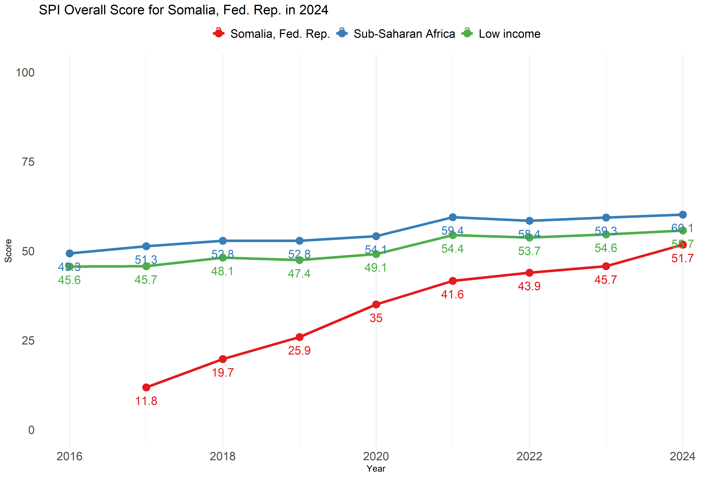
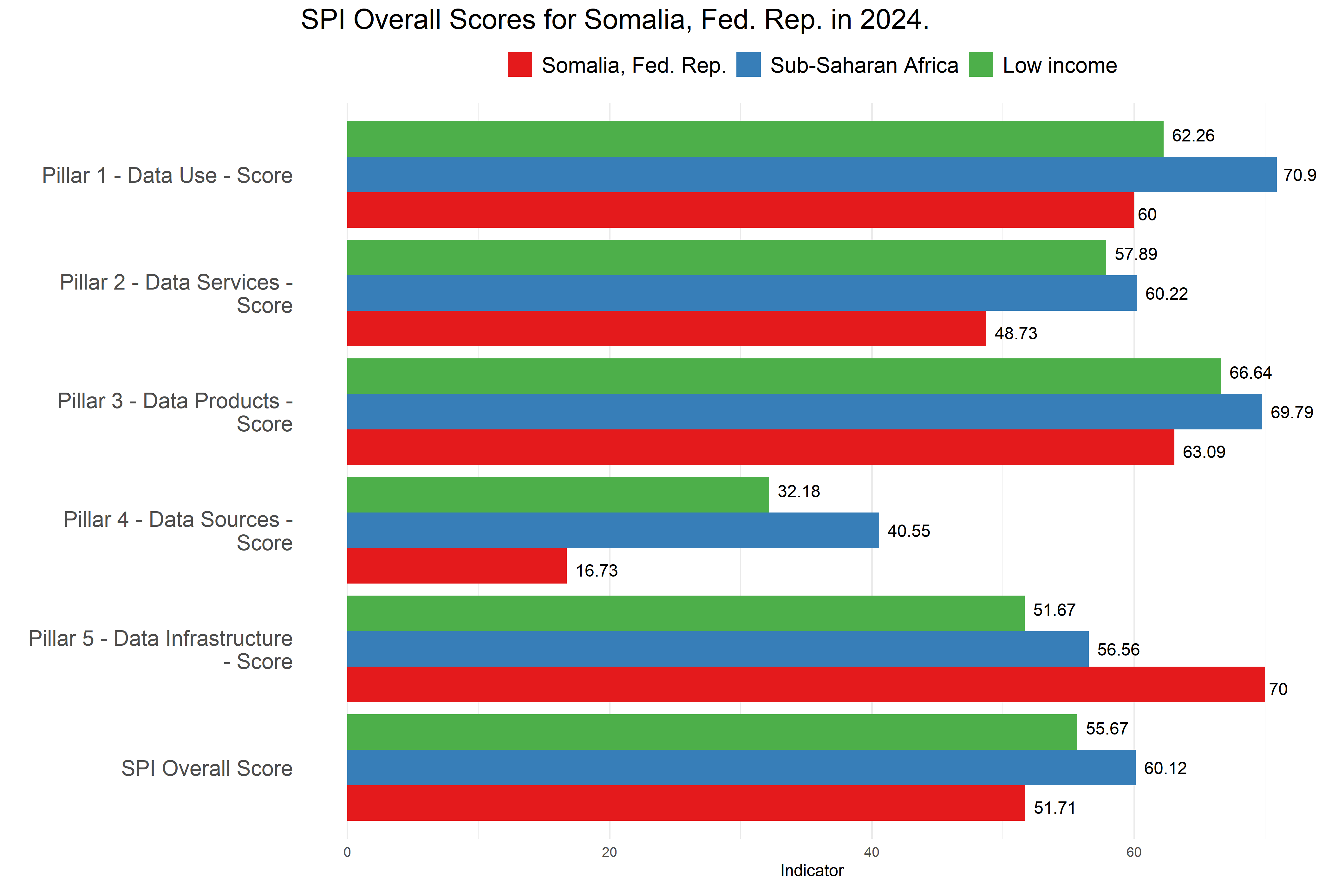

Pillar 1: Data Use
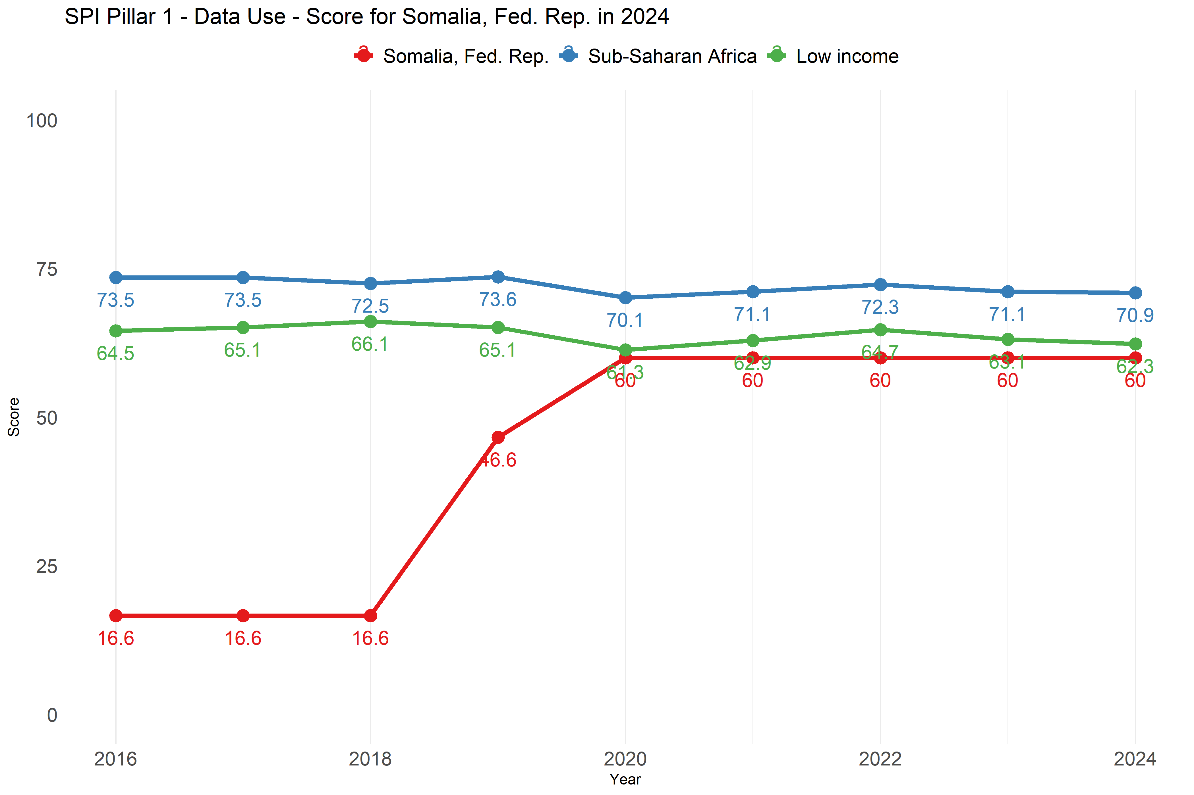
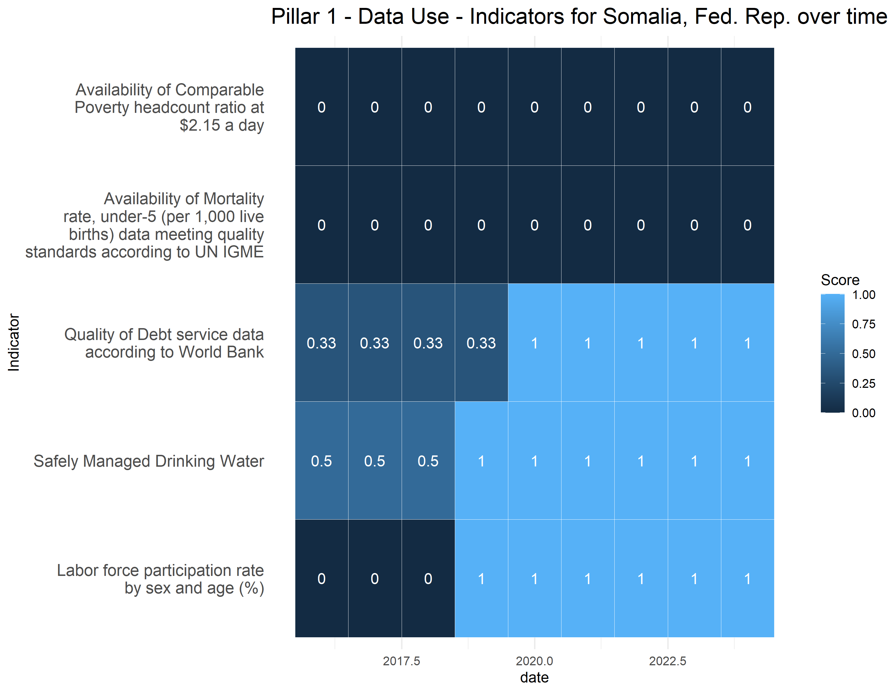

Pillar 2: Data Services
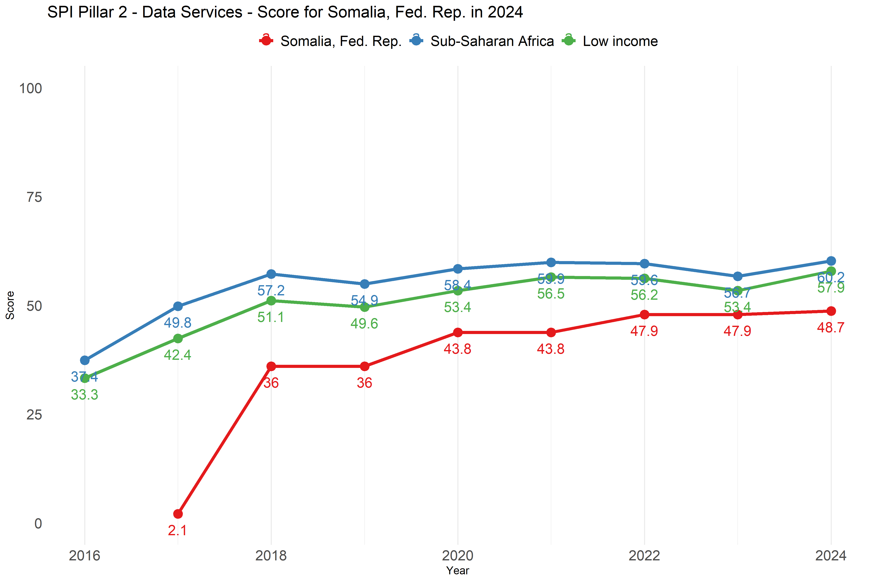
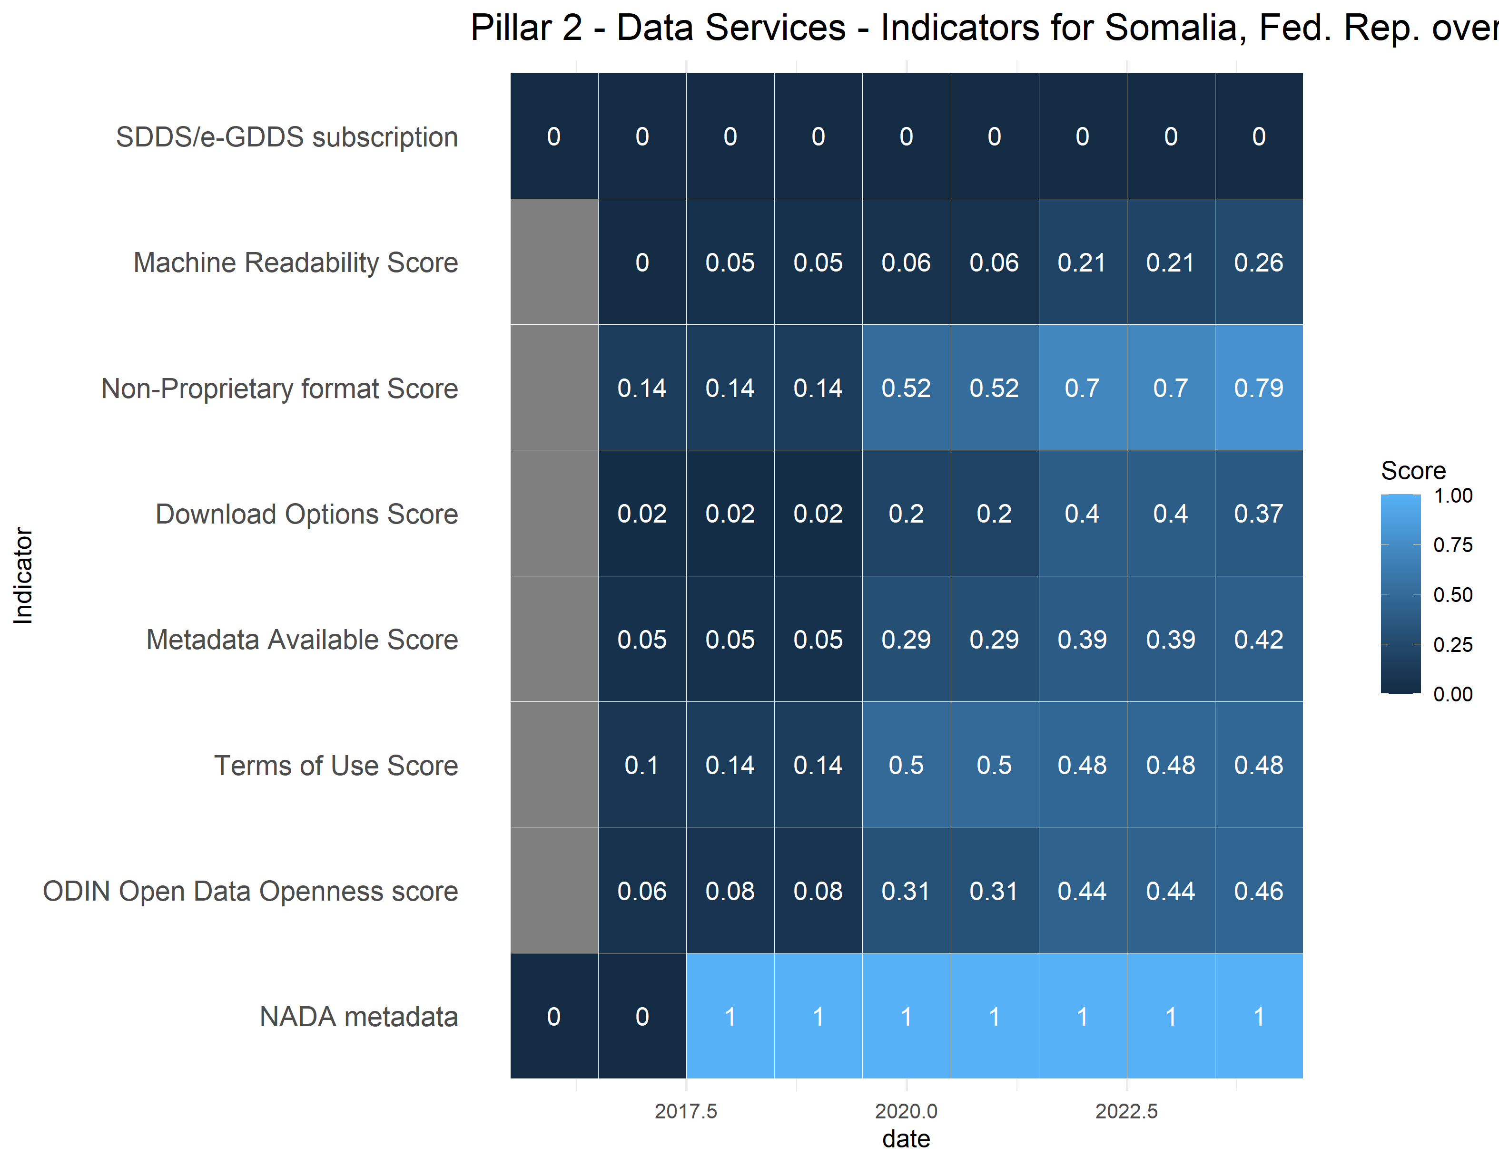

Pillar 3: Data Products
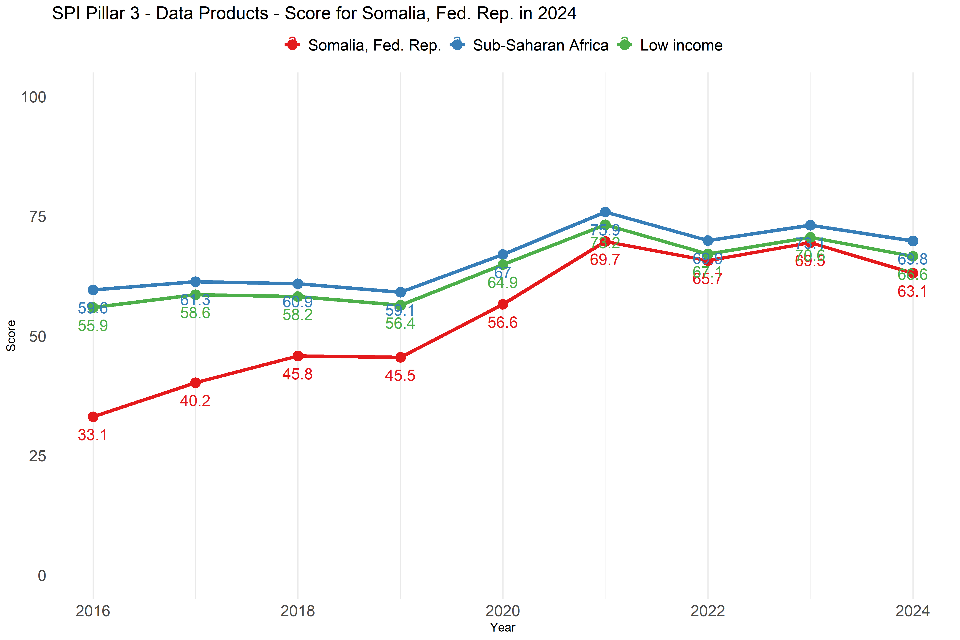
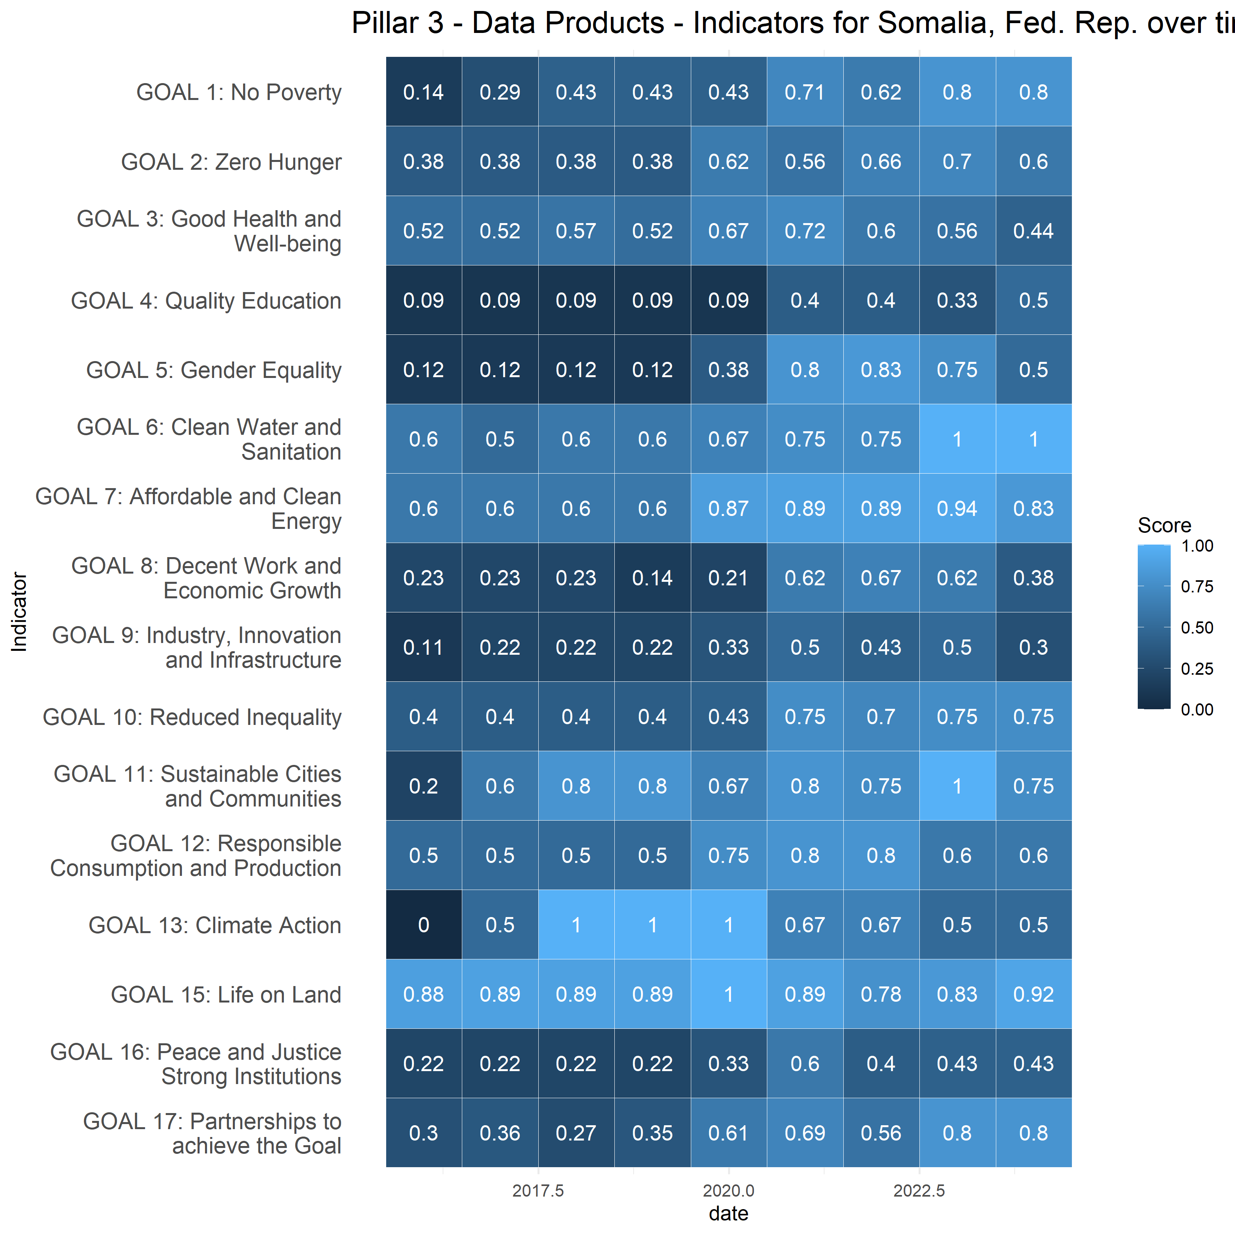

Pillar 4: Data Sources
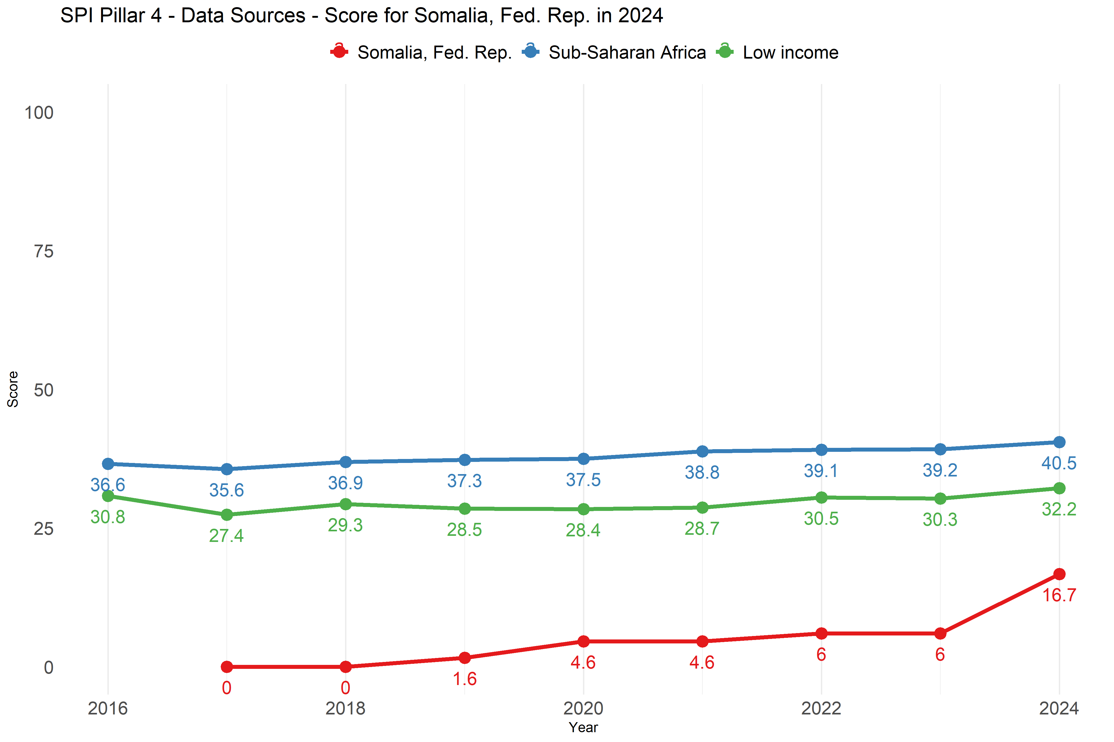
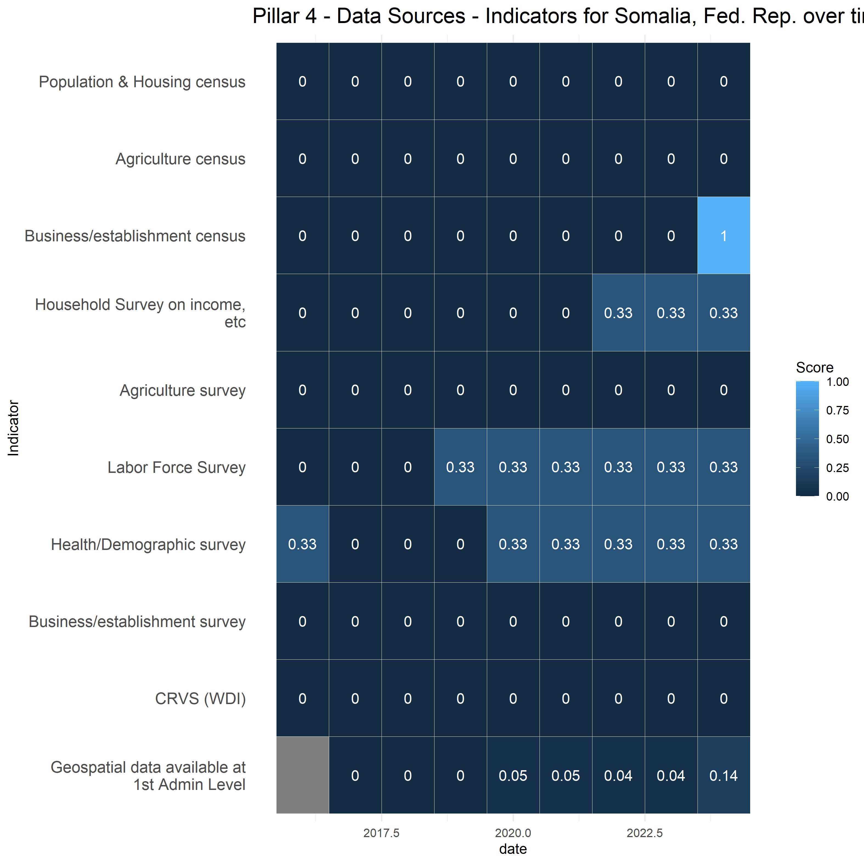

Pillar 5: Data Infrastructure
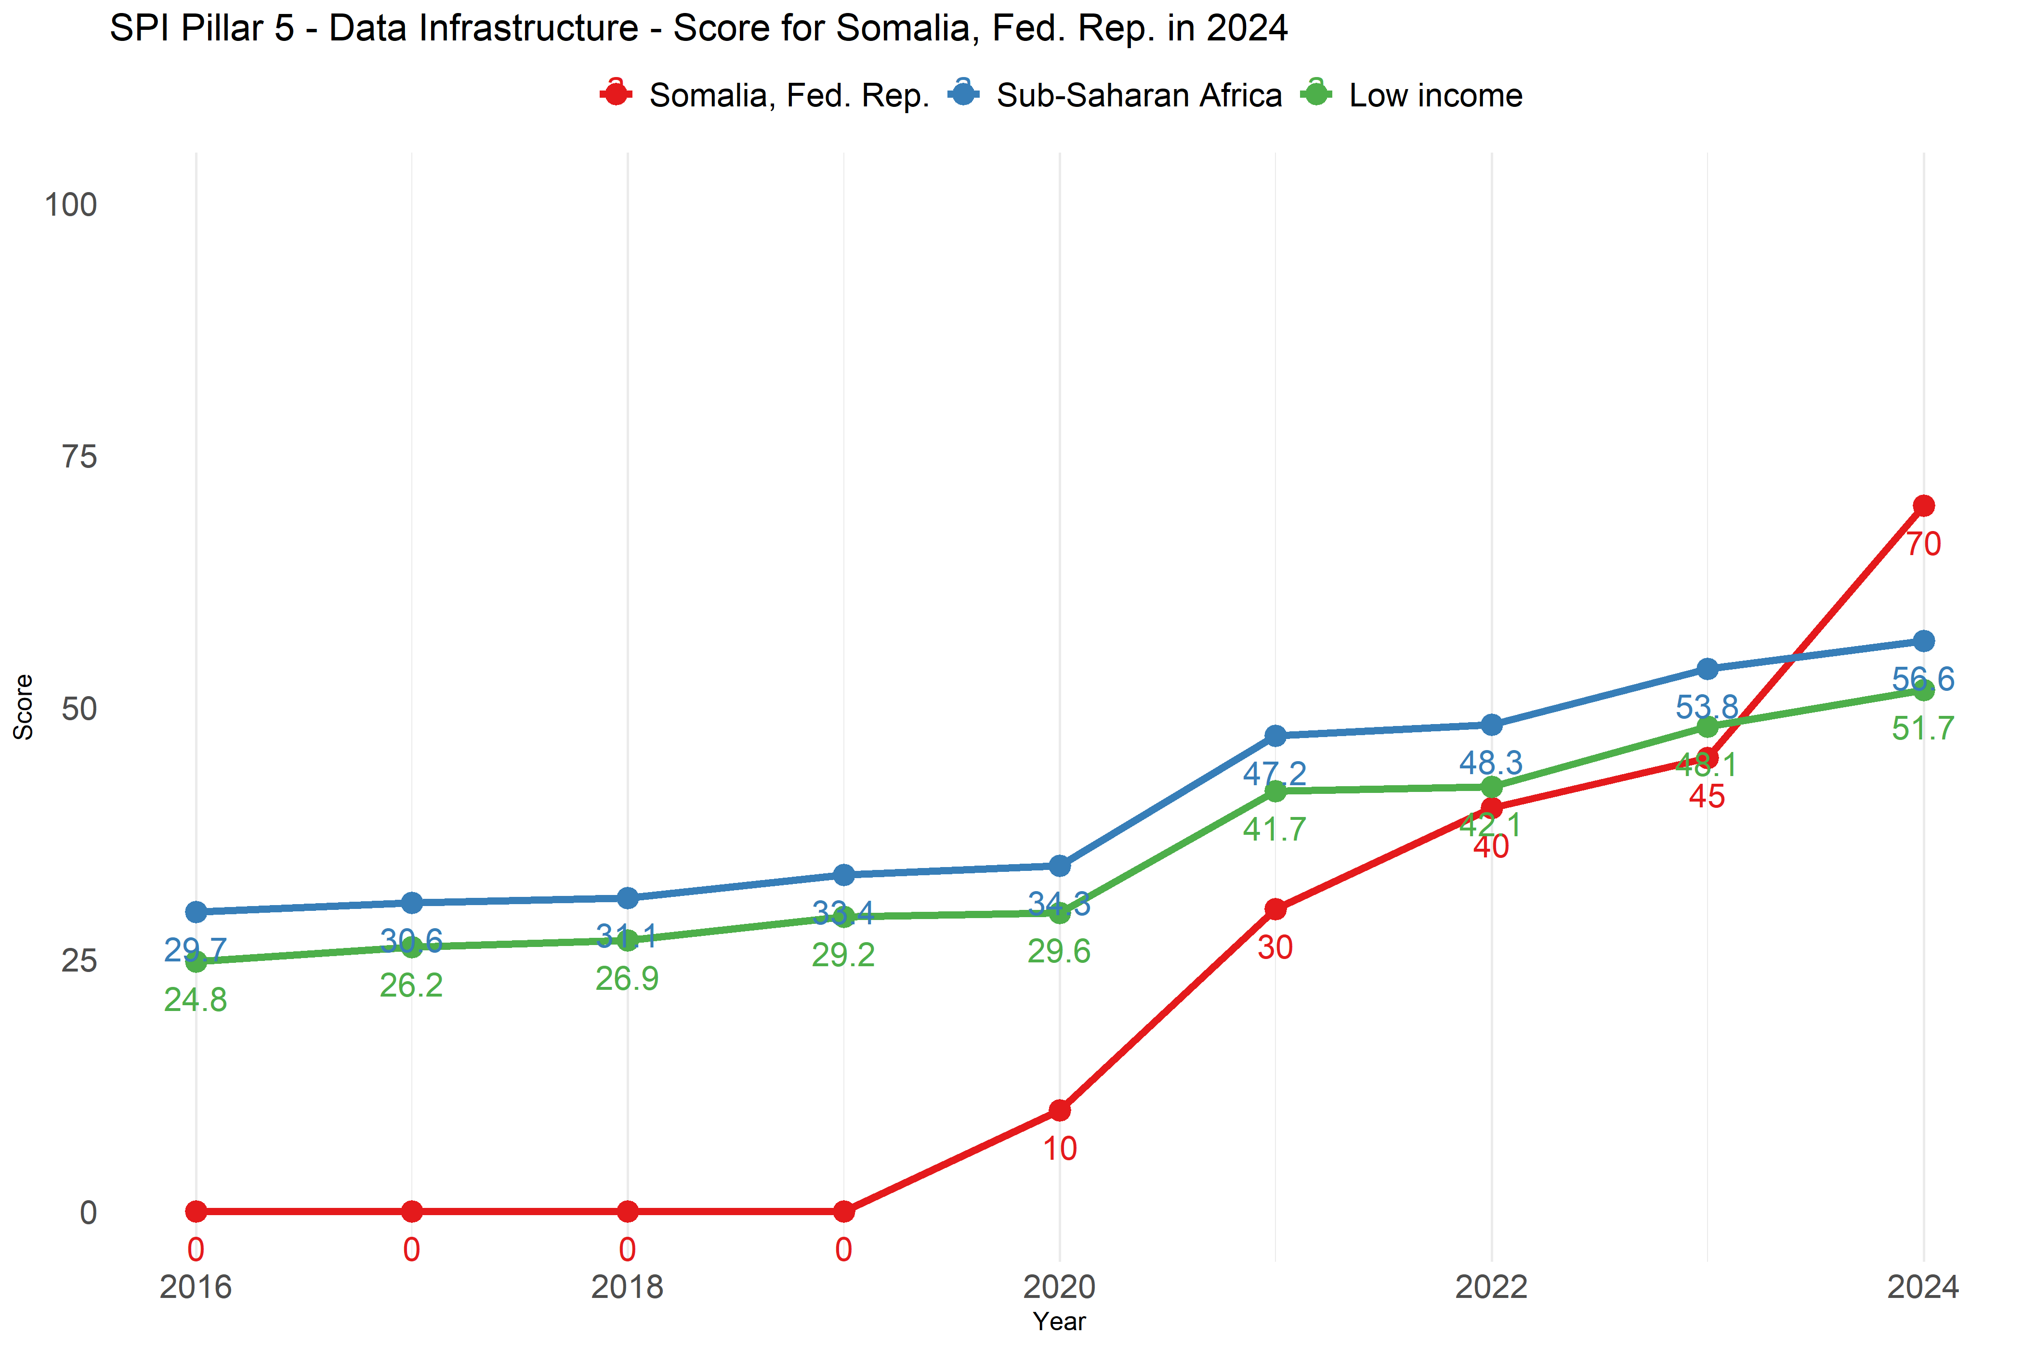
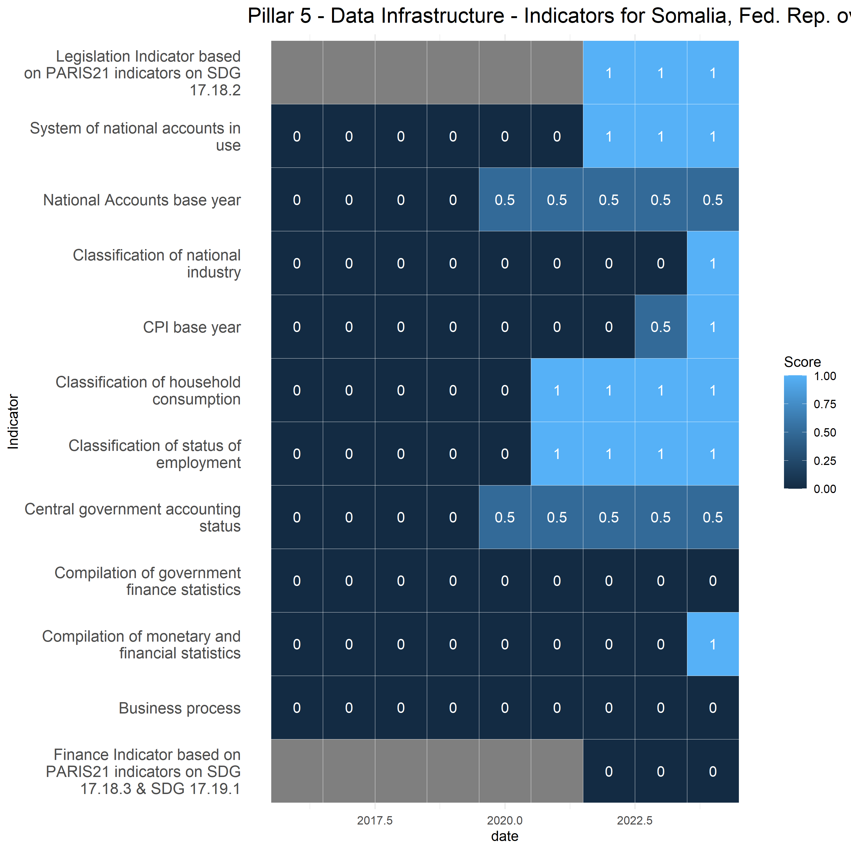

By Indicator
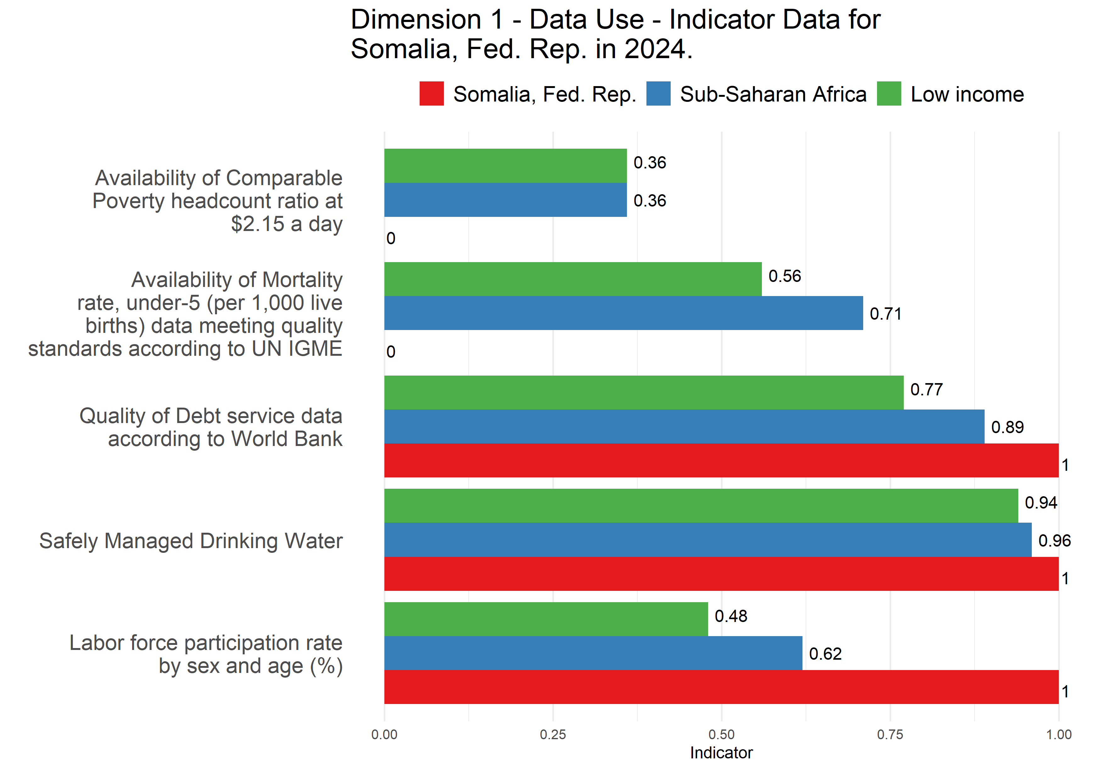
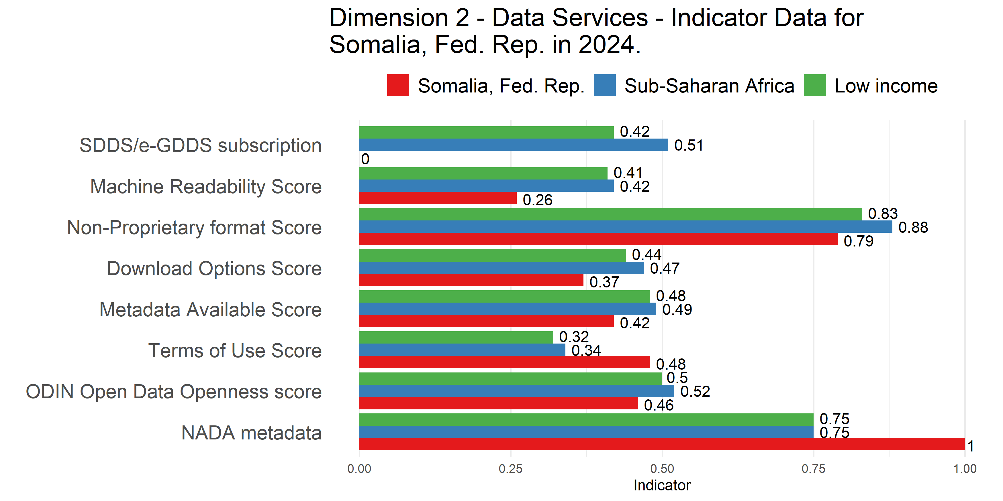
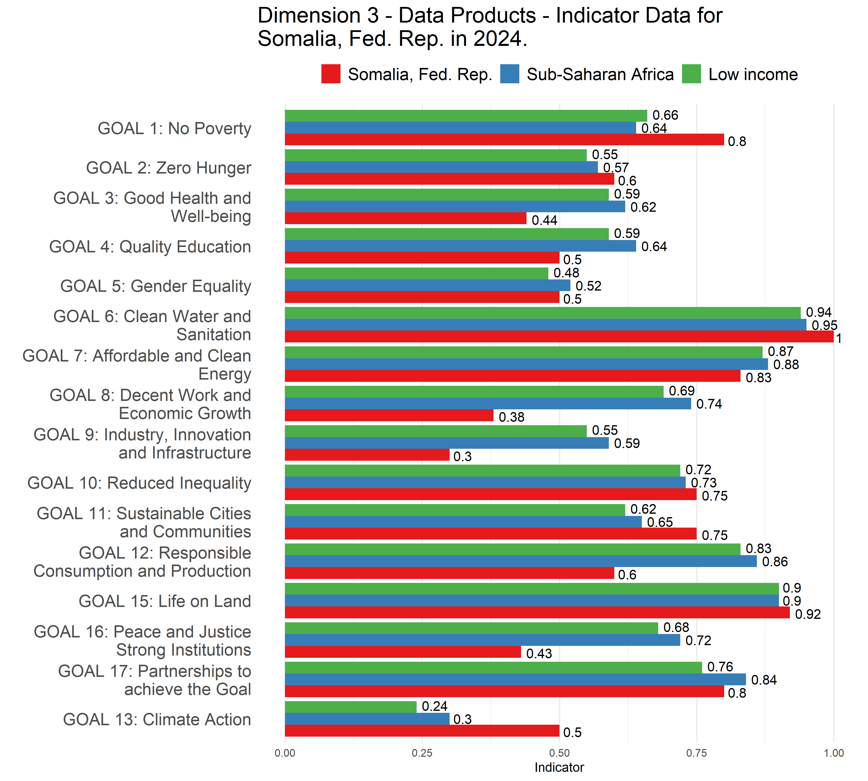
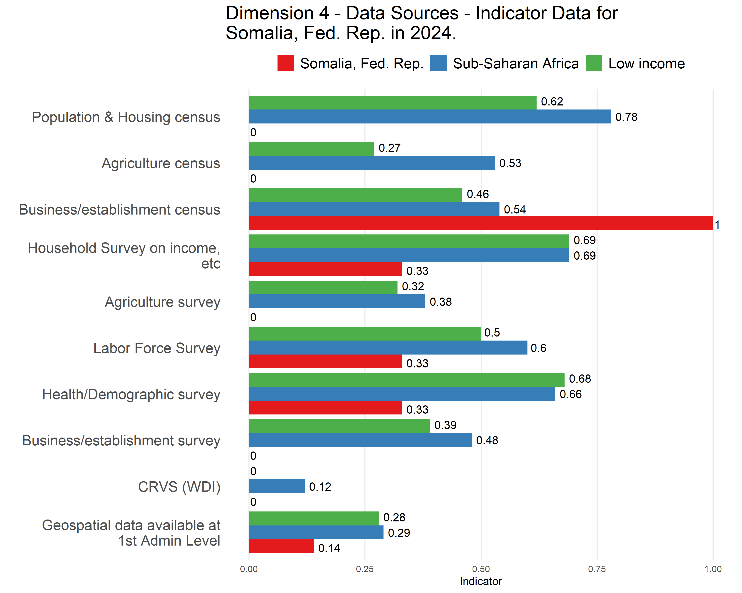
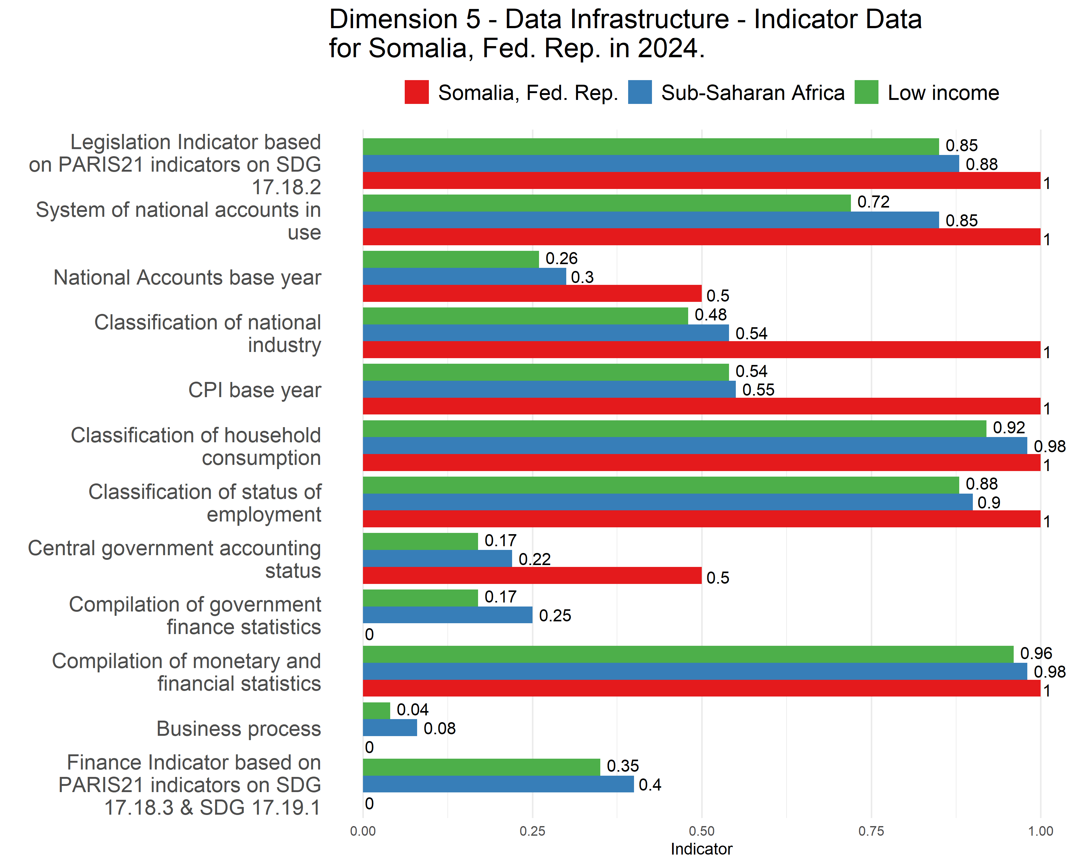

Table of Raw Indicators and Scores

Censuses and Surveys
Somalia, Fed. Rep. SPI Indicator Data in 2024.
Indicator | Scored Value | Census/Survey Dates
Population & Housing census | 0 | -99
Agriculture census | 0 | -99
Business/establishment census | 1 | 2024
Household Survey on income, etc | 0.33 | 1985, 2022
Agriculture survey | 0 | -99
Labor Force Survey | 0.33 | 2019, -99
Health/Demographic survey | 0.33 | 2000, 2006, 2020
Business/establishment survey | 0 | -99

Methods Standard
Somalia, Fed. Rep. SPI Indicator Data in 2024.
Indicator | Scored Value | Method, Standard, or Classification
System of national accounts in use | 1 | Country uses the 2008 System of National Accounts methodology
National Accounts base year | 0.5 | 2022
Classification of national industry | 1 | rev4
CPI base year | 1 | Not Applicable/Available
Classification of household consumption | 1 | Not Applicable/Available
Classification of status of employment | 1 | Not Applicable/Available
Central government accounting status | 0.5 | Not Applicable/Available
Compilation of government finance statistics | 0 | Not Applicable/Available
Compilation of monetary and financial statistics | 1 | Not Applicable/Available
Business process | 0 | Not Applicable/Available

ANNEX: Information on Scoring of Indicators
More information can be found at the following resource:
https://worldbank.github.io/SPI/technical-documentation-of-spi-indicators.html
Indicator Name | Brief Description | Scoring
Availability of Comparable Poverty headcount ratio at $2.15 a day | Comparability data from World Bank’s PIP | 1 Point. Comparable data lasting at least two years within past 5 years. 0.5 Point. Comparable data lasting at least two years within past 10 years. 0 Points. No comparable data within past 5 years
Availability of Mortality rate under-5 (per 1000 live births) data meeting quality standards | Child Mortality Metadata from UN IGME | 1 Point. Two indicators that met UN IGME standards within past 5 years. 0.5 Point. Two indicators that met UN IGME standards within past 10 years. 0 Points. No data that met UN IGME standards within past 10 years
Quality of Debt service data according to World Bank | Debt Reporting Metadata from World Bank | 1 Points. Actual value. 0.67 Points. Preliminary value. 0.33 Points. Estimated value. 0 Points. No value
Safely Managed Drinking Water | Availability of Safely Managed Drinking Water data for use by JMP | 1 Point. At least two estimates with breakdowns for urban/rural areas within an 8 year window. 0.5 Points. At least two estimates but not an urban/rural breakdown within an 8 year window. 0 Points. Otherwise
Labor force participation rate by sex and age (%) | Labor force participation data for use by ILO | 1 Point. Country has a labor force survey based estimate in past 5 years of labor force participation broken down by total male and female & estimated value from ILO is within 10 percentage points of value reported by national government. 0.5 Point. Country has labor force survey or is within 10 points of ILO but not both. 0 Points. Otherwise
SDDS/e-GDDS subscription | The Special Data Dissemination Standard (SDDS) and electronic General Data Dissemination Standard (e-GDDS) were established by the International Monetary Fund (IMF) for member countries that have or that might seek access to international capital markets to guide them in providing their economic and financial data to the public. Although subscription is voluntary the subscribing member needs to be committed to observing the standard and provide information about its data and data dissemination practices (metadata). The metadata are posted on the IMF’s SDDS and e-GDDS websites. | Point. Subscribing to IMF SDDS+ or SDDS standards. 0.5 Points. Subscribing to IMF e-GDDS standards. 0 Points. Otherwise
ODIN Open Data Openness score | ODW Openness score | Our source for this indicator is Open Data Watch. Scores range from 0-100. For more details consult the ODIN technical documentation.
NADA metadata | NADA/NSO websites. Statistical systems must be open and transparent about their methods and procedures and provide access to adequate metadata – detailed descriptions of the methods and procedures used to produce microddata. | 1 Point. Yes available. 0 Points. No.
GOAL 1: No Poverty | SDG Goal 1 data availability. Source: UN Global SDG Indicators Database | Fraction of Indicators in Goal 1 with value produced by country’s statistical system within a 5-year window.
GOAL 2: Zero Hunger | SDG Goal 2 data availability. Source: UN Global SDG Indicators Database | Fraction of Indicators in Goal 2 with value produced by country’s statistical system within a 5-year window.
GOAL 3: Good Health and Well-being | SDG Goal 3 data availability. Source: UN Global SDG Indicators Database | Fraction of Indicators in Goal 3 with value produced by country’s statistical system within a 5-year window.
GOAL 4: Quality Education | SDG Goal 4 data availability. Source: UN Global SDG Indicators Database | Fraction of Indicators in Goal 4 with value produced by country’s statistical system within a 5-year window.
GOAL 5: Gender Equality | SDG Goal 5 data availability. Source: UN Global SDG Indicators Database | Fraction of Indicators in Goal 5 with value produced by country’s statistical system within a 5-year window.
GOAL 6: Clean Water and Sanitation | SDG Goal 6 data availability. Source: UN Global SDG Indicators Database | Fraction of Indicators in Goal 6 with value produced by country’s statistical system within a 5-year window.
GOAL 7: Affordable and Clean Energy | SDG Goal 7 data availability. Source: UN Global SDG Indicators Database | Fraction of Indicators in Goal 7 with value produced by country’s statistical system within a 5-year window.
GOAL 8: Decent Work and Economic Growth | SDG Goal 8 data availability. Source: UN Global SDG Indicators Database | Fraction of Indicators in Goal 8 with value produced by country’s statistical system within a 5-year window.
GOAL 9: Industry Innovation and Infrastructure | SDG Goal 9 data availability. Source: UN Global SDG Indicators Database | Fraction of Indicators in Goal 9 with value produced by country’s statistical system within a 5-year window.
GOAL 10: Reduced Inequality | SDG Goal 10 data availability. Source: UN Global SDG Indicators Database | Fraction of Indicators in Goal 10 with value produced by country’s statistical system within a 5-year window.
GOAL 11: Sustainable Cities and Communities | SDG Goal 11 data availability. Source: UN Global SDG Indicators Database | Fraction of Indicators in Goal 11 with value produced by country’s statistical system within a 5-year window.
GOAL 12: Responsible Consumption and Production | SDG Goal 12 data availability. Source: UN Global SDG Indicators Database | Fraction of Indicators in Goal 12 with value produced by country’s statistical system within a 5-year window.
GOAL 13: Climate Action | SDG Goal 13 data availability. Source: UN Global SDG Indicators Database | Fraction of Indicators in Goal 13 with value produced by country’s statistical system within a 5-year window.
GOAL 14: Life Below Water | SDG Goal 14 data availability. Source: UN Global SDG Indicators Database | Fraction of Indicators in Goal 14 with value produced by country’s statistical system within a 5-year window.
GOAL 15: Life on Land | SDG Goal 15 data availability. Source: UN Global SDG Indicators Database | Fraction of Indicators in Goal 15 with value produced by country’s statistical system within a 5-year window.
GOAL 16: Peace and Justice Strong Institutions | SDG Goal 16 data availability. Source: UN Global SDG Indicators Database | Fraction of Indicators in Goal 16 with value produced by country’s statistical system within a 5-year window.
GOAL 17: Partnerships to achieve the Goal | SDG Goal 17 data availability. Source: UN Global SDG Indicators Database | Fraction of Indicators in Goal 17 with value produced by country’s statistical system within a 5-year window.
Population & Housing census (Availability score over 20 years) | Population censuses collect data on the size, distribution, and composition of population and provide sampling frames for household and other surveys. | 1 Point. Population census done within last 10 years. 0.5 Points. Population census done within last 20 years. 0 Points. Otherwise.
Agriculture census (Availability score over 20 years) | Agriculture censuses collect information on agricultural activities such as size of holding, land tenure, land use, employment, and production. | 1 Point. Census done within last 10 years. 0.5 Points. Census done within last 20 years. 0 Points. Otherwise.
Business/establishment census (Availability score over 20 years) | Business/establishment censuses provide valuable information on all economic activities, number of employed, and size of establishments. | 1 Point. Census done within last 10 years. 0.5 Points. Census done within last 20 years. 0 Points. Otherwise.
Household Survey on income etc. (Availability score over 10 years) | These surveys collect data on household income (including income in kind), consumption, and expenditure. It is recommended that surveys be conducted at least every 3 to 5 years. | 1 Point. 3 or more surveys done within past 10 years. 0.67 Points. 2 surveys done within past 10 years. 0.33 Points. 1 survey done within past 10 years. 0 Points. None within past 10 years.
Agriculture survey (Availability score over 10 years) | Agricultural surveys refer to surveys of agricultural holdings based on the sampling frames established by the agricultural census. | 1 Point. 3 or more surveys done within past 10 years. 0.67 Points. 2 surveys done within past 10 years. 0.33 Points. 1 survey done within past 10 years. 0 Points. None within past 10 years.
Labor Force Survey (Availability score over 10 years) | Labor force survey is a standard household-based survey of work-related statistics at the national and sub-national level. | 1 Point. 3 or more surveys done within past 10 years. 0.67 Points. 2 surveys done within past 10 years. 0.33 Points. 1 survey done within past 10 years. 0 Points. None within past 10 years.
Health/Demographic survey (Availability score over 10 years) | Health surveys collect information on various aspects of health of populations. It is recommended that health surveys be conducted at least every 3 to 5 years. | 1 Point. 3 or more surveys done within past 10 years. 0.67 Points. 2 surveys done within past 10 years. 0.33 Points. 1 survey done within past 10 years. 0 Points. None within past 10 years.
Business/establishment survey (Availability score over 10 years) | The business/establishment survey provides information on employment, hours, and earnings of employees from a sample of business establishments. | 1 Point. 3 or more surveys done within past 10 years. 0.67 Points. 2 surveys done within past 10 years. 0.33 Points. 1 survey done within past 10 years. 0 Points. None within past 10 years.
Social Protection Admin (ASPIRE) | Administrative data available on social protection programs from ASPIRE (World Bank) databases | Scoring is 1 if administrative data is available to produce beneficiary counts or expenditures for any social protection and labor program. 0 otherwise.
Civil Registration and Vital Statistics (CRVS) system | Birth registrations 90% complete and death registration 75% complete according to UNSD. | Score is 1 if both complete. 0.5 if one of two is complete. 0 if neither complete.
Geospatial data available at 1st Admin Level | Indicator data availability at sub-national levels | Our source for this indicator is Open Data Watch. Indicator is whether data is available at the first administrative level. Scores range from 0-100.
Legislation Indicator based on PARIS21 indicators on SDG 17.18.2 | Existence of National Statistical Council, national statistical strategy, and plan. Also includes legislative aspects such as freedom of information, privacy, and good governance. | Score is 1 if the country has a national statistical legislation compliant with UN Fundamental Principles of Statistics. 0 otherwise.
System of national accounts in use | The national accounts data are compiled using the System of National Account 2008 (SNA2008) or European System of National and Regional Accounts (ESA 2010). | 1 point for using SNA2008 or ESA 2010. 0.5 points for using SNA 1993 or ESA 1995. 0 points otherwise.
National Accounts base year | National accounts base year is the year used for constant price calculations. | 1 point for chained price. 0.5 for reference period within past 10 years. 0 points otherwise.
Classification of national industry | The industrial production data are compiled using International Standard Industrial Classification (ISIC) Rev.4 or Statistical Classification of Economic Activities in the European Community (NACE) Rev.2. | 1 Point. Latest version adopted. 0.5 Points. Previous version. 0 Points otherwise.
CPI base year | Consumer Price Index reflects changes in the cost of acquiring a fixed basket of goods and services by the average consumer. | 1 Point. Annual chain linking. 0.5 Points. Base year in last 10 years. 0 Points otherwise.
Classification of household consumption | Classification of Individual Consumption According to Purpose (COICOP) used in household budget surveys and international GDP comparisons. | 1 Point. Follow COICOP. 0 Points otherwise.
Classification of status of employment | Classification of status of employment data using the International Classification of Status in Employment (ISCE-93). | 1 Point. Follow ISCE-93 or 2012 North American Industry Classification System (NAICS). 0 Points otherwise.
Central government accounting status | Government finance accounting status follows noncash recording basis. | 1 Point. Follows noncash recording basis. 0.5 Points. Follows cash recording basis. 0 Points otherwise.
Compilation of government finance statistics | Compilation of government finance statistics follows the Government Finance Statistics Manual (GFSM). | 1 Point. Follows GFSM 2014. 0.5 Points. Follows GFSM 2001. 0 Points otherwise.
Compilation of monetary and financial statistics | Compilation of monetary and financial statistics follows the Monetary and Financial Statistics Manual (MFSM). | 1 Point. Follows MFSM 2000 or the Compilation Guide (2008/2016). 0 Points otherwise.
Business process | The Generic Statistical Business Process Model (GSBPM) describes statistics production in a general and process-oriented way. | 1 Point. GSBPM is in use. 0 Points otherwise.
Finance Indicator based on PARIS21 indicators on SDG 17.18.3 & SDG 17.19.1 | Indicator based on PARIS21 SDG indicators (national statistical plan that is fully funded and under implementation). | Score is 1 if the country has a national statistical plan that is fully funded and under implementation. 0 otherwise.

